**MicroROS Zephyr Installation Guideline**

**Created by Marlar Chan**

1. **MicroROS Setup**

<https://micro-ros.github.io/docs/tutorials/core/first_application_rtos/zephyr/>

# Source the ROS 2 installation

$source /opt/ros/foxy/setup.bash

#Create a workspace and download the micro-ROS build

$mkdir zephy_test

$cd zephy_test

$git clone -b $ROS_DISTRO https://github.com/micro-ROS/micro_ros_setup.git src/micro_ros_setup

#Update dependencies using rosdep

$sudo apt update && rosdep update

$rosdep install --from-path src --ignore-src -y

#Install Pipe

sudo apt-get install python3-pip

#Colcon Installation [Need to install once]

$sudo apt install python3-colcon-common-extensions

#Build micro-ROS tools and source them

colcon build

source install/local_setup.bash

#Create firmware for build-in Board

ros2 run micro_ros_setup create_firmware_ws.sh zephyr stm32f429i_disc1

Modify CMakeList.txt Line 5 to below

*firmware/zephyr_apps/app/ping_pong/CMakeLists.txt*

set(COMPATIBLE_BOARDS stm32f429i_disc1 disco_l475_iot1 olimex_stm32_e407 native_posix nucleo_h743zi nucleo_f746zg)

#Firmware Configuration

$source /opt/ros/foxy/setup.bash

$source install/local_setup.bash

$ros2 run micro_ros_setup configure_firmware.sh ping_pong --transport serial --dev 1

*[--dev is for UART1]*

#Build firmware

ros2 run micro_ros_setup build_firmware.sh

#Hex File can be found in the following location

*/uros_ws/firmware/build/zephyr*

**Flashing Firmware to Board**

* USART1 use for running microROS agent.  
  (PA9 and PA10)
* **No need NSH for Zephyr**

ST-Link Debug

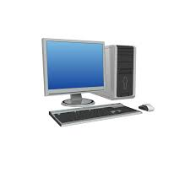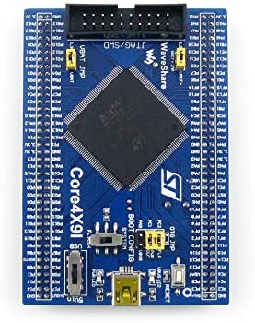

Power Supply

USART1

USB_NSH

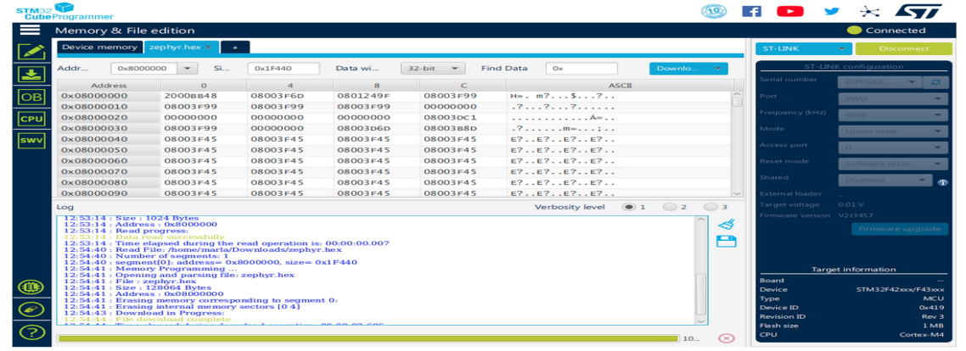

**Create and Build Agent**

New Terminal

$cd microros_waveshare/

$source /opt/ros/foxy/setup.bash

$source install/local_setup.bash

$ros2 run micro_ros_setup create_agent_ws.sh

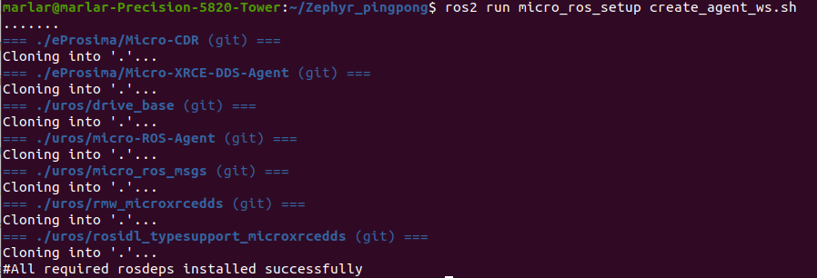

$ros2 run micro_ros_setup build_agent.sh

**Running Agent**

source /opt/ros/foxy/setup.bash

source install/local_setup.bash

ros2 run micro_ros_agent micro_ros_agent serial --dev /dev/ttyUSB0 -v 6



**UROS PingPong Testing**

Add New terminal,

source /opt/ros/foxy/setup.bash

source install/local_setup.bash

# Subscribe to micro-ROS ping topic

ros2 topic echo /microROS/ping

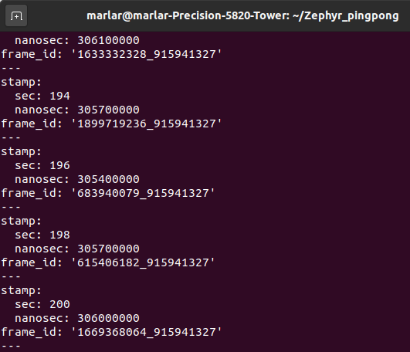

Add New terminal,

$source /opt/ros/foxy/setup.bash

$source install/local_setup.bash

# Subscribe to micro-ROS pong topic

$ros2 topic echo /microROS/pong

**Add New terminal,**

$source /opt/ros/foxy/setup.bash

$source install/local_setup.bash

# Send a fake ping

ros2 topic pub --once /microROS/ping std_msgs/msg/Header '{frame_id: "fake_ping"}'



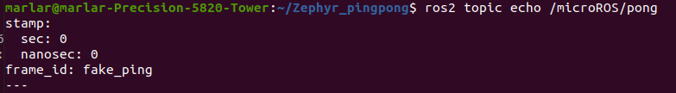

Add New terminal,

$source /opt/ros/foxy/setup.bash

$source install/local_setup.bash

micro-ROS pong publisher will answer with a pong. As a consequence, in the pong subscriber console, we should see the board’s answer to our fake_ping

ros2 topic echo /microROS/pong

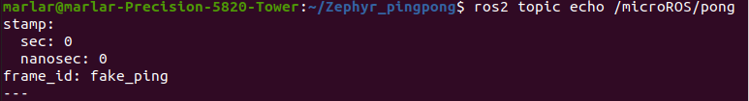

MicroROS Sensor Test

# Source the ROS 2 installation

source /opt/ros/foxy/setup.bash

# Create a workspace and download the micro-ROS tools

$mkdir zephyr_microros

$cd zephyr_microros

#Download src folder which include micro_ros_setup

$git clone -b $ROS_DISTRO https://github.com/micro-ROS/micro_ros_setup.git src/micro_ros_setup

# Update dependencies using rosdepsudo apt update && rosdep update

rosdep install --from-path src --ignore-src -y

# Install pipsudo apt-get install python3-pip

# Build micro-ROS tools and source them

colcon buildsource install/local_setup.bash

#Create Firmware

$ros2 run micro_ros_setup create_firmware_ws.sh zephyr stm32f429i_disc1

Create demo adxl372_test

1. Copy Pingpong folder and rename as adxl372_test.
2. Compare with adxl372 directory

Firmware/zephyrproject/zephyr/samples/sensor/ adxl372

Copy Src/main.c into adxl372_test.

#To modify CMakeList.txt Line 5 to below

firmware/zephyr_apps/app/adxl372_test/CMakeLists.txt

set(COMPATIBLE_BOARDS stm32f429i_disc1 disco_l475_iot1 olimex_stm32_e407 native_posix nucleo_h743zi nucleo_f746zg)

firmware/zephyr_apps/app/adxl372_test/boards/

Copy nrf52dk_nrf52832.overlay and paste it in the same folder.

Rename it to stm32f429i_disc1.overlay.

Edit as follow

&spi5 {

cs-gpios = <&gpioe 4 GPIO_ACTIVE_LOW>;

adxl372@0 {

compatible = "adi,adxl372";

reg = <0>;

spi-max-frequency = <8000000>;

label = "ADXL372";

int1-gpios = <&gpioe 6 GPIO_ACTIVE_HIGH>;

};

};

/**** SPI5, PE4 is CS, PE6 is INT1 ******************/

Default Settings is ADXL372_PEAK_DETECT_MODE.

If you want to change to ADXL372_MEASUREMENT_MODE,

Go to /zephyrproject/zephyr/drivers/sensor/adxl372/

Edit Kconfig: Line 30 to

choice

prompt "Operating mode"

default ADXL372_MEASUREMENT_MODE

#Compile Firmwrae

source /opt/ros/foxy/setup.bash

source install/local_setup.bash

ros2 run micro_ros_setup configure_firmware.sh adxl372_test --transport serial --dev 1

#Build Firmware

ros2 run micro_ros_setup build_firmware.sh